ROWAN-SALISBURY SCHOOL SYSTEM

PHYSICIAN’S AUTHORIZATION FORM FOR PRESCRIPTION
AND NON-PRESCRIPTION MEDICATION

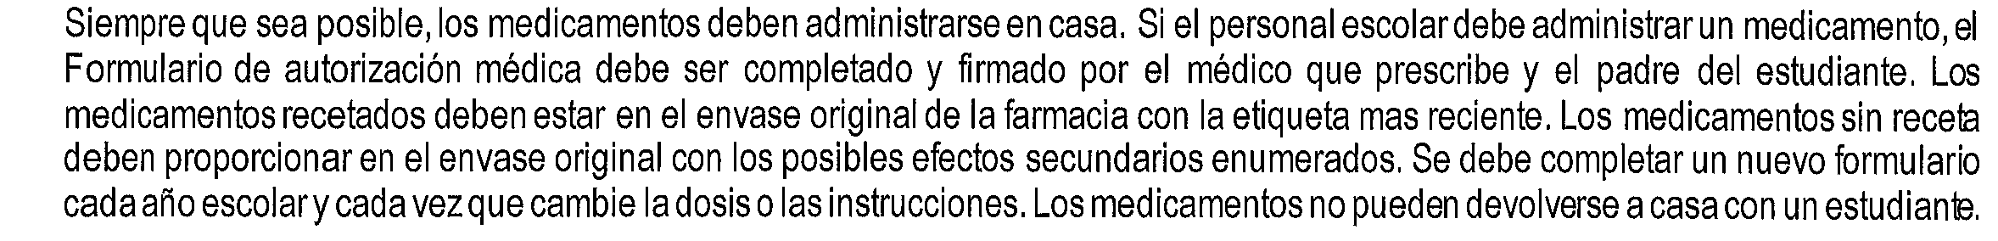
Student Name: __________________________________ Date of Birth: __________________________________
School: ________________________________________ Teacher/Grade: ________________________________
Medication: _____________________________________ Diagnosis/Code: ________________________________
(ONE MEDICATION PER FORM)
Dose: _________________________________________ Relationship to meals:  Before  After  N/A
Storage Requirements:  None  Refrigerate
Directions for administration:
 Daily at Time(s):__________________________
 As Needed (provide specific instructions): _____________________________________________________________
________________________________________________________________________________________________
Medication type:  Tablet/Capsule  Liquid  Inhaler  Patch  Drops  Injection  Rectal  Nasal
Date medication is to start:_____________________________ Date medication is to end:_______________________
Time medication is administered at home:_________________ Possible side effects:____________________________
Allergies: Medication:______________________ Food:______________________ Other:______________________
SELF ADMINISTRATION OF MEDICATIONS (FOR PHYSICIAN’S USE ONLY)
Asthma inhalers, epi-pens, and diabetic supplies may be carried & self-administered according to North Carolina State Law with a physician’s signature.

 _______ (Physician’s Initials) I agree this student demonstrates the knowledge & skill necessary to self-medicate (limited to
asthma inhalers, epi-pens, and diabetic supplies)

To maintain this student’s optimum health and to maximize educational performance and attendance, it is necessary that this medication be given during school hours according to the above instructions.

______________________________________________
Physician’s Signature

______________________________ _________________
Telephone Number Date
Clinic Stamp
++++++++++++++++++++++++++++++++++++++++++++++++++++++++++++++++++++++++++++++++++++++++++++++++++++++++++++++++++++++
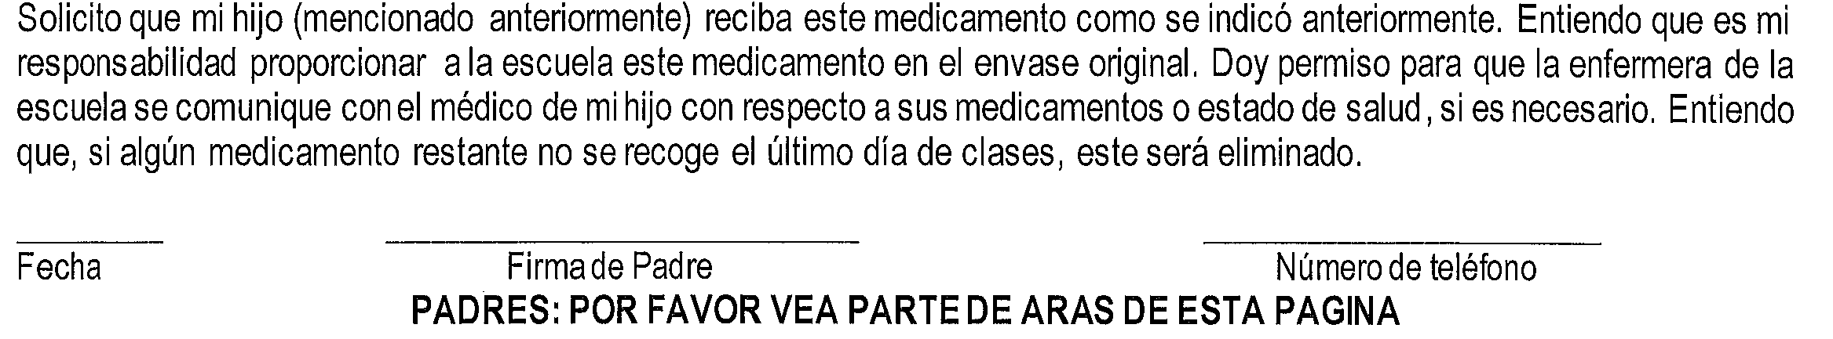
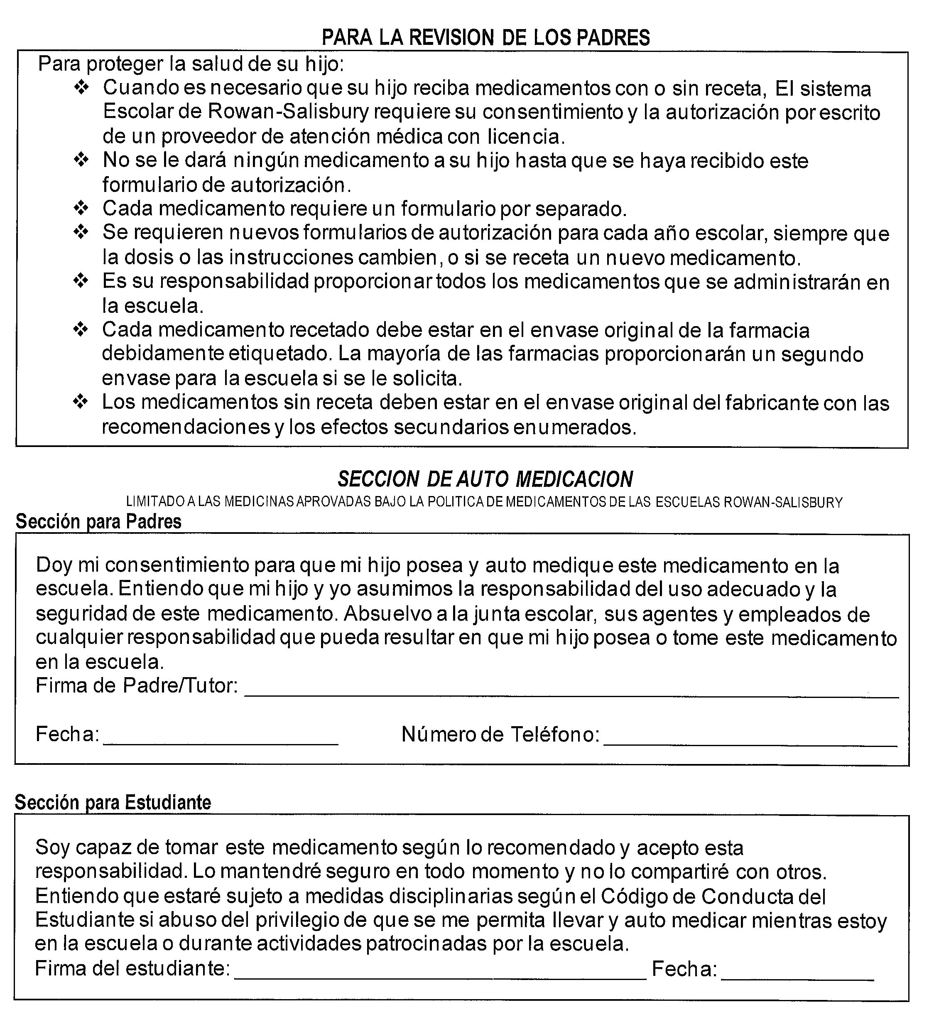

School Nurse Section
I have reviewed this request & agree that this student has demonstrated he/she understands when & how to self-administer this medication.

School nurse or designee signature: _______________________________________ Date: ________________

In compliance with federal law, the Rowan-Salisbury School System administers all education programs, employment activities, and admissions without discrimination because of race, religion, national or ethnic origin, color, age, military service, disability, or gender, except where exemption is appropriate
and allowed by law.
(REVISED 1/23

